**HTML**

**Html consists of a series of elements**

**Html describes the structure of a web page**

**Html elements label pieces of content such as "this is a heading", "this is a paragraph", "this is a link", etc.**

**Html elements tell the browser how to display the content**

**Html is the standard markup language for creating web pages**

**Html stands for hypertext markup language**

* **HTML is not a programming language; it is a markup language.**
* **A markup language is a set of markup tags.**
* **HTML is W3C Recommendation.**
* **HTML language isn’t case- sensitive, and doesn’t affect by spaces and line breaks.**
* **HTML is Browser Dependent language.**

HTML FORMATTING

|  |  |
| --- | --- |
| **<b>text</b>** | **writes text as bold** |
| **<strong> text </strong>** | **Important text** |
| **<I>text</I>** | **writes text in italics** |
| **<em> text </em>** | **Emphasized text** |
| **<u>text</u>** | **writes underlined text (Deprecated)** |
| **<sub>text</sub>** | **lowers text and makes it smaller** |
| **<sup>text</sup>** | **lifts text and makes it smaller** |
| **<del>text</del>** | **strikes a line through the text** |

|  |  |
| --- | --- |
| **<small> text </small>** | **Define Smaller text than the container** |
| **<mark> text </mark>** | **Marked or highlighted text** |
| **<font> text </font>** | **Defines font size, name and color (Deprecated).** |
| **<center>text</center>** | **Show the text on Center (Deprecated).** |

**HTML <b> and <strong> tag**

The HTML <b> is a physical tag used to simply make text bold.

<p> This text is <b>bold</b>. </p>

**Browser Output**

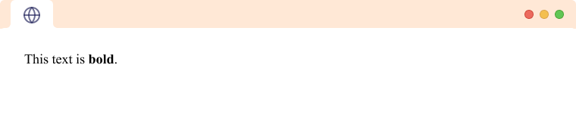

The HTML <strong> tag is a semantic tag that is used to signify that the text inside the tag is of higher importance. This is shown by making the text bold.

<p> The text is <strong>strong</strong>. </p>

**Browser Output**

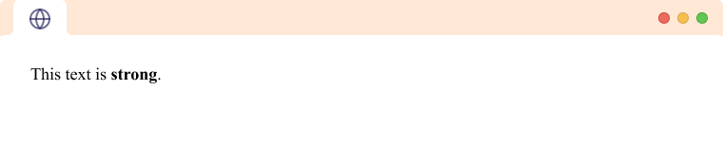

**HTML <i> and <em> tag**

The HTML <i> tag is a physical tag used to make the text italic. It is used to indicate foreign text, scientific nomenclature, thoughts, etc.

<p> This text is <i>italic</i>. </p>

**Browser Output**

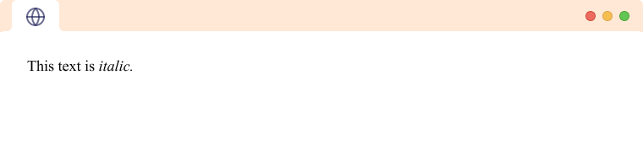

The HTML <em> tag is a semantic tag that is used to signify that the text inside the tag is being emphasized. It is a semantic tag as opposed to <i>, which doesn't hold any semantic meaning.

<p> This text is <em>emphasized</em>.</p>

**Browser Output**

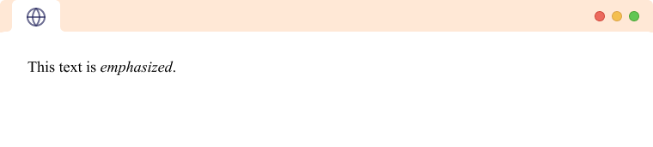

**HTML <u> tag**

The HTML <u> tag is a physical tag used to make the text underlined.

<p> This text is <u>underlined</u>. </p>

**Browser Output**

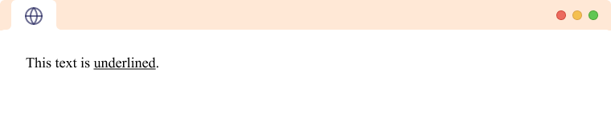

**HTML <sup> and <sub> tag**

The HTML <sup> tag is used to create superscript text. The text is placed half a character height above other text and is a size smaller.

<p> This text is <sup>superscripted</sup>. <p>

**Browser Output**

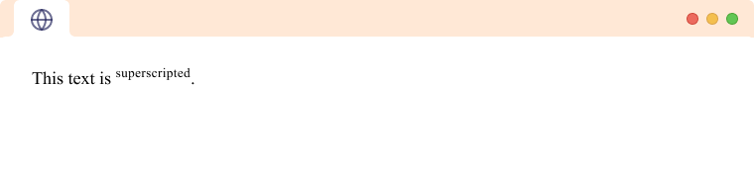

The HTML <sub> tag is used to create subscript text. The text is placed half a character height below other text and is a size smaller.

<p> This text is <sub>subscripted</sub>. <p>

**Browser Output**

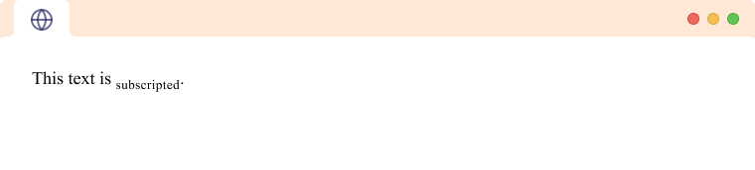

**HTML <ins> and <del> tag**

The HTML <del> tag is a semantic tag used to represent that the text is deleted or changed.

<p> This text is <del>deleted</del>. </p>

**Browser Output**

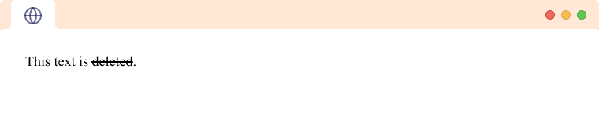

The HTML <ins> tag is a semantic tag used to represent that the text has been inserted in the document. The <ins> tag generally follows some deleted text.

<p> This text is <del>deleted</del> <ins>inserted</ins>. </p>

**Browser Output**

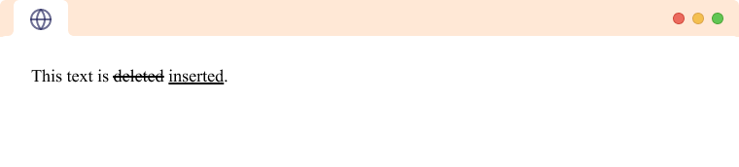

**HTML <big> and <small> tag**

The HTML <big> tag is a physical tag used to make text one font size larger than the surrounding text.

<p> This text is <big>bigger</big>. </p>

**Browser Output**

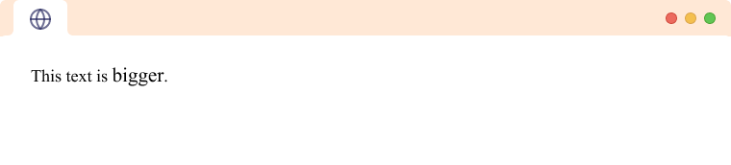

The HTML <small> tag is a physical tag used to make text one font size smaller than the surrounding text.

<p> This text is <small>smaller</small>. </p>

**Browser Output**

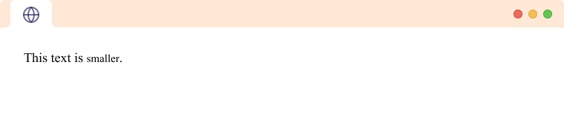

**HTML <mark> tag**

The HTML <mark> tag is a physical tag that is used to highlight text.

<p> This text is <mark>marked</mark>. </p>

**Browser Output**

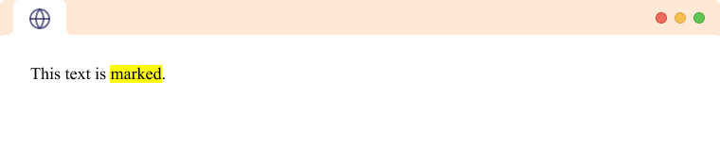

**HTML Video**

The**<video>** element in HTML allows you to embed video content directly into web pages. It supports various video formats, including MP4, WebMD, and Ogg. In this guide, we’ll learn about the key features of HTML5 video. video and audio tags are introduced in HTML5.

**Basic Syntax**

To include a video on your webpage, use the following syntax:

<video src="" controls> </video>

The src attribute specifies the URL of the video file

The controls attribute adds default video controls (play, pause, volume, etc.).

**Additional Attributes**

| **Attributes** | **Description** |
| --- | --- |
| [**Autoplay**](https://www.geeksforgeeks.org/html-video-autoplay-attribute/) | Starts playing the video automatically. |
| [**Preload**](https://www.geeksforgeeks.org/html-video-preload-attribute/) | Provides a hint to the browser about the best user experience. |
| [**Loop**](https://www.geeksforgeeks.org/html-video-loop-attribute/) | Automatically loops the video. |
| [**height**](https://www.geeksforgeeks.org/html-video-height-attribute-2/) | It sets the height of the video in CSS pixels. |
| [**width**](https://www.geeksforgeeks.org/html-video-width-attribute/) | It determines the width of the video display area on the web page. |
| [**Controls**](https://www.geeksforgeeks.org/html-video-controls-attribute/) | It shows the default video controls like play, pause, volume, etc. |
| [**Muted**](https://www.geeksforgeeks.org/html-video-muted-attribute/) | Mutes the audio. |
| [**Poster**](https://www.geeksforgeeks.org/html-video-poster-attribute/) | Displays an image preview before video loading. |

**Example Usage of HTML Video**

**1. Adding Video with Preload**

**Example:**We have embedded the HTML video along with the source link and preload functionality.

<!DOCTYPE html>

<html>

​<body>

<center>

<h1 style="color:green;">GeeksforGeeks</h1>

<h3>HTML video tag</h3>

<p>Adding video on the webpage</p>

<video width="450" height="250"

controls preload="auto">

<source src="https://media.geeksforgeeks.org/wp-content

/uploads/20190616234019/Canvas.move_.mp4"

type="video/mp4">

<source src="https://media.geeksforgeeks.org/wp-content

/uploads/20190616234019/Canvas.move_.ogg"

type="video/ogg">

</video>

</center>

</body>

​

</html>

**Output:**

Video Player

00:00

HTML Audio

**Syntax**

<audio>  
 <source src="sample.mp3" type="audio/mpeg">  
</audio>

**Attributes**

The various attributes that can be used with the “audio” tag are listed below:

| **Attributes** | **Description** |
| --- | --- |
| [**Controls**](https://www.geeksforgeeks.org/html-controls-attribute/) | Designates what controls to display with the audio player. |
| [**Autoplay**](https://www.geeksforgeeks.org/html-autoplay-attribute/) | Designates that the audio file will play immediately after it loads controls. |
| [**muted**](https://www.geeksforgeeks.org/html-muted-attribute/) | Designates that the audio file should be muted. |
| [**src**](https://www.geeksforgeeks.org/html-src-attribute/) | Designates the URL of the audio file. |
| [**Loop**](https://www.geeksforgeeks.org/html-loop-attribute/) | Designates that the audio file should continuously repeat. |

**Autoplay audio**

The autoplay attribute is used to automatically begin playback of the audio file whenever the URL of the webpage is loaded.

HTML

<!DOCTYPE html>

<html>

​

<body>

<audio controls autoplay>

<source src=

"https://media.geeksforgeeks.org/wp-content/uploads/20230524142525/gfg_offline_classes_en.mp3"

type="audio/mp3">

<source src=

"https://media.geeksforgeeks.org/wp-content/uploads/20220913101124/audiosample.ogg"

type="audio/mp3">

</audio>

</body>

​

</html>

HTML I frame

An iframe, or Inline Frame, is an HTML element represented by the <iframe> tag. It functions as a ‘window’ on your webpage through which visitors can view and interact with another webpage from a different source.

Iframes are used for various purposes like:

**Embedding Multimedia**: Easily integrate videos, audio, or animations from platforms like YouTube, etc.

**Including Maps**: Embed maps from services like Google Maps directly into your site.

**Loading Forms and Widgets**: Incorporate forms or widgets from other sources without writing complex code.

**Syntax:**

<iframe src="URL" title="description"></iframe>

The **src** attribute specifies the **URL** of the document you want to embed.

Iframes can include **videos**, **maps**, or **entire web pages** from other sources.

**HTML Iframes Examples**

**Example 1: Basic Iframe Embedding**

In this example, an iframe is used to display another webpage within the current webpage.

HTML

<!DOCTYPE html>

<html>

​

<head>

<title>HTML iframe Tag</title>

</head>

​

<body style="text-align: center">

<h2>HTML iframe Tag</h2>

<iframe src=

"https://media.geeksforgeeks.org/wp-content/uploads/20240206111438/uni2.html"

height="370"

width="400">

</iframe>

</body>

​

</html>